**Virtualization:**

Virtualization creates a virtual version of underlying services, enabling multiple operating systems and applications to run simultaneously on the same hardware, improving utilization and flexibility.

Storage Virtualization:

* **Storage virtualization** is the process of abstracting and pooling physical storage resources to create a unified, logical storage environment.
* In cloud computing, storage virtualization allows for efficient and flexible storage management, improving scalability, accessibility, and resource utilization.

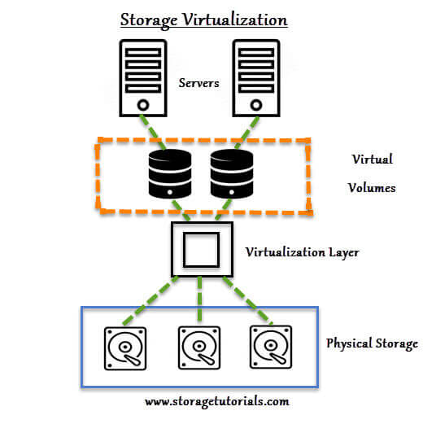

**Key Features of Storage Virtualization:**

1. **Abstraction**:  
   Physical storage devices (e.g., hard drives, SSDs) are abstracted into a single logical storage pool, making it easier for users and applications to access and manage storage.
2. **Pooling**:  
   Multiple physical storage resources can be combined into a single, unified virtual storage space, allowing for better resource allocation and utilization.
3. **Flexibility**:  
   Storage can be easily scaled up or down based on demand, allowing cloud providers to allocate storage resources dynamically as needed.
4. **Efficiency**:  
   By abstracting storage, virtualization optimizes resource allocation and reduces waste, improving the overall efficiency of storage management.
5. **Centralized Management**:  
   Storage virtualization allows administrators to manage storage resources from a centralized platform, simplifying tasks like provisioning, monitoring, and maintenance.

**Types of Storage Virtualization:**

* **Block-level Virtualization**:  
  Virtualizes storage at the block level, creating virtual storage volumes for applications and OS, commonly used in SANs.
* **File-level Virtualization**:  
  Virtualizes storage at the file level, enabling unified access to files across different physical devices, typically used in NAS.
* **Object Storage Virtualization**:  
  Virtualizes data as objects in distributed systems, accessed through APIs, commonly used in cloud storage platforms like AWS S3 or Google Cloud Storage.

Benefits of Storage Virtualization:

* **Improved Resource Utilization**:  
  Virtualizing storage allows for more efficient use of physical storage devices, reducing wastage and maximizing available capacity.
* **Scalability**:  
  Storage can be expanded or contracted quickly and easily to meet changing demands, offering the flexibility needed in cloud environments.
* **Cost Savings**:  
  By pooling resources and reducing the need for dedicated hardware, storage virtualization helps lower infrastructure costs.
* **Simplified Management**:  
  A centralized management platform for storage resources makes it easier to perform administrative tasks, such as provisioning, monitoring, and backup.

Challenges of Storage Virtualization:

* **Complexity in Setup**:  
  Implementing storage virtualization requires careful planning and configuration, particularly when integrating with existing infrastructure.
* **Performance Overhead**:  
  Virtualization can introduce some performance overhead, especially if the underlying physical storage is not properly optimized.
* **Security Concerns**:  
  As multiple tenants share virtualized storage resources in cloud environments, securing data and ensuring proper access control becomes crucial.
* **Data Migration**:  
  Migrating data between physical and virtualized storage systems, or between different virtualized environments, can be complex and time-consuming.